Sri Lanka Institute of Information

Technology

LAB 06

**IT24100671**

**Weerasingha M.P.D.P.**

**IT2120 - Probability and Statistics**

Q1) 

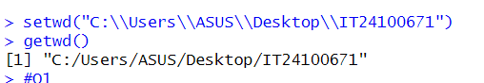

Q2)



